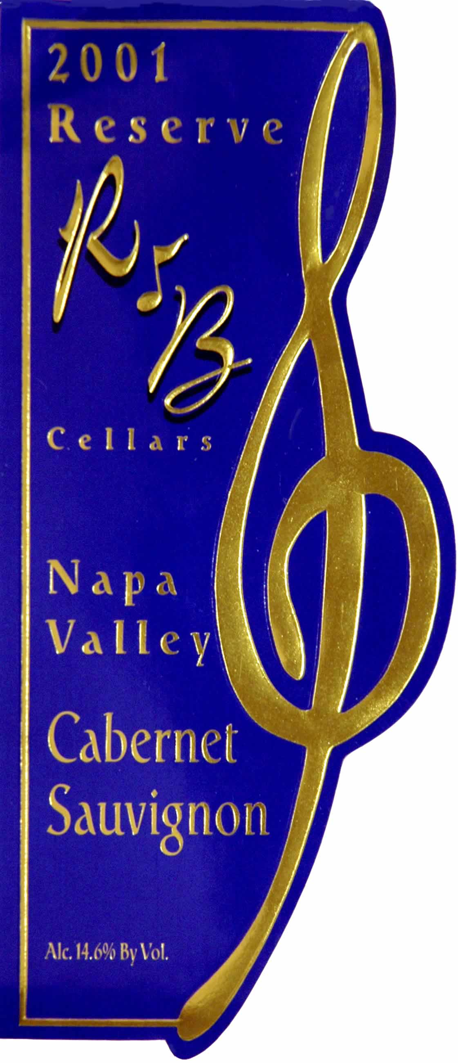 | 2001  Napa Valley  Cabernet Sauvignon  Reserve
  Vineyard: | 100% Napa Valley  Rutherford Bench-7%  Yountville West Vineyard  Mt. Veeder Yates Ranch  Vineyard-93%
  Composition: | 90% Cabernet Sauvignon  7% Merlot  3% Petite Verdot
  Harvest Date:  Sugar at Harvest:  Total Acid:  ph: | Oct 20 ~ Nov 3, 2001  24.7 Degrees Brix  .68 gm/cl  3.48
  Fermentation: | Hand picked, 5 days cold soak at 50 degrees, pumped over 3 times a day, fermentation temp. to 90 degrees, extended maceration for 20 days, D-80 and Monte Rosso yeast.
  Aging: | 22 months in 100% French Oak from 7 different French Coopers; Vicard, Seguin Moreau, St. Martin, Billon, Trieul, Taransaud and Francois Freres, 80% new oak.
  Bottling Date: | October 2003
  Release Date: | April 2005
  Production | 1100 750ml Cases

Vineyards
Yates Ranch ~ This very mountainous, hillside vineyard is located 1200 feet above the valley floor on Mt. Veeder and dates back to the 1880s. These hillside Cabernet vines were replanted in the early 1970s to a very small berry clone that produces an intense mountain wine. The small amounts of Merlot and used in this wine are also planted here. Yields are generally 1-2 tons per acre.

Yountville West Vineyard ~ This spectacular vineyard is nestled on the west slope of the Rutherford Bench just North and West of Yountville. This mature Merlot vineyard is almost 50 years old and produces modest yields of 2-3 tons per acre.

Cellar Practices and Winemaking
Perfectly ripe grapes were harvested in late October early November 2001. They were crushed into a stainless tank and cold soaked at 50°F for 5 days. The temperature was increased to 70°F, and cultured yeast fermentation started and lasted thirty days at a peak temperature of 90°F. The grapes were gently pressed and the resulting wine racked into 60 gallon barrels, which were 100% French (80% being new oak) from seven different French coopers: Vicard, Seguin Moreau, St. Martin, Billon, Trieul, Taransaud and Francois Freres. The Cabernet was blended in the classical way with small amounts of Merlot added from the same vineyards. The wine was aged for 22 months in oak and given an additional 12 months of bottle age prior to release.

Winemaker’s Comments
This 2001 R&B Reserve Napa Valley Cabernet Sauvignon is an extraordinary wine with remarkable depth and complexity. It exhibits a huge core of dark black cherry fruit with elements of dark black currant, tea, smoked duck, and violets in the bouquet. The small addition of Merlot and Petite Verdot adds softness, color and a touch of sweet cherries. The flavors of dark black berries, currants, chocolate, and cassis are evident, with a huge juicy blackberry finish. This wine is a classic Cabernet Sauvignon with all of the exotic spice and layers of fruit you would expect from a Reserve wine.

