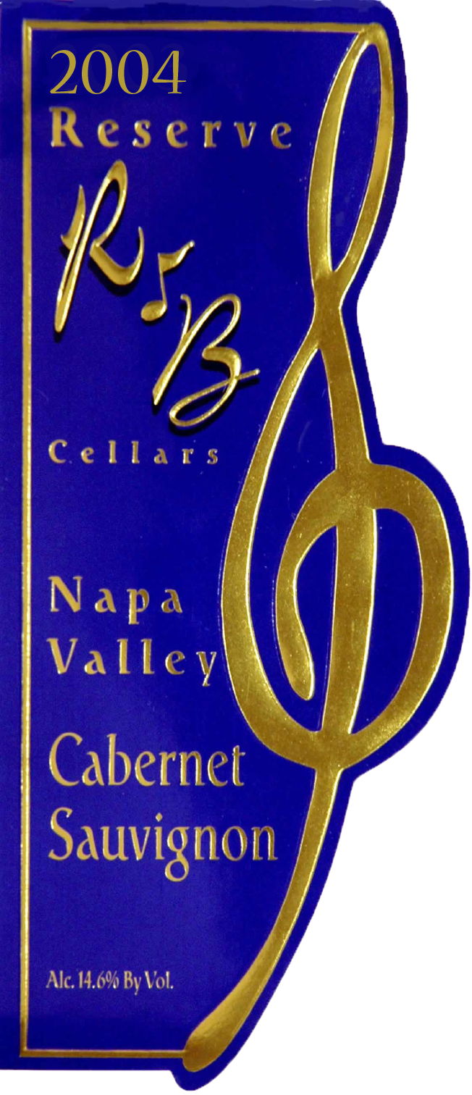 | 2004  Napa Valley  Cabernet Sauvignon  Reserve
  Vineyard: | 97% Napa Valley  3% El Dorado  97% Bingham Ranch  Calistoga  3% Verbitsky Ranch
  Composition: | 97% Cabernet Sauvignon  3 % Cabernet Franc
  Harvest Date:  Sugar at Harvest:  Total Acid:  ph: | Oct 27 ~ Nov 4, 2007  25.2 Degrees Brix  .69 gm/cl  3.37
  Fermentation: | Hand picked, 5 days cold soak at 50 degrees, pumped over 3 times a day, fermentation temp. to 90 degrees, extended maceration for 20 days, D-80 and Monte Rosso yeast.
  Aging: | 28 months in 100% French Oak from 10 different French Coopers; Vicard, Seguin Moreau, St. Martin, Billon, Trieul, Taransaud, Francois Freres, Ermitage, Jarnac, and Bel Air 100% new oak.
  Bottling Date: | April 2007
  Release Date: | May 2008
  Production | 700 750ml Cases

Vineyard
Bingham Ranch - The Bingham Ranch in Calistoga is one of the oldest cabernet vineyards in the Napa Valley, dating back to 1850s. There are two parcels of vines used in our cabernet, one is 55 years old and the other is 35 years. It is a small berry clone with very low yields, approximately one and a half tons per acre. The resulting fruit is very intensely flavored with a rich dark blackberry profile that makes intensely structured cabernet sauvignon.

Cellar Practices and Winemaking
Perfectly ripe grapes were harvested in late October early November 2004. They were crushed into a stainless tank and cold soaked at 50°F for 5 days. The temperature was increased to 70°F, and cultured yeast fermentation started and lasted thirty days at a peak temperature of 90°F. The grapes were gently pressed and the resulting wine racked into barrels, which were 100% new French oak 60 gallon barrels from ten different French coopers: Vicard, Seguin Moreau, St. Martin, Billon, Trieul, Taransaud, Francois Freres, Ermitage,Jarnac, and Bel Air. The Cabernet was blended in the classical way with small amounts of Cabernet Franc added from an El Dorado vineyard. The wine was aged for 28 months in oak and given an additional 12 months of bottle age prior to release.

Winemaker’s Comments
This 2004 R&B Reserve Napa Valley Cabernet Sauvignon is an extraordinary wine with remarkable depth and complexity. It exhibits a huge core of dark black cherry fruit with elements of dark black currant, tea, smoked duck, and violets in the bouquet. The small addition of Cabernet Franc adds softness, color and a touch of sweet cherries. The flavors of dark black berry, currants, chocolate, and cassis are evident, with a huge juicy blackberry finish. This wine is a classic Cabernet Sauvignon with all of the exotic spice and layers of fruit you would expect from a Reserve wine.

