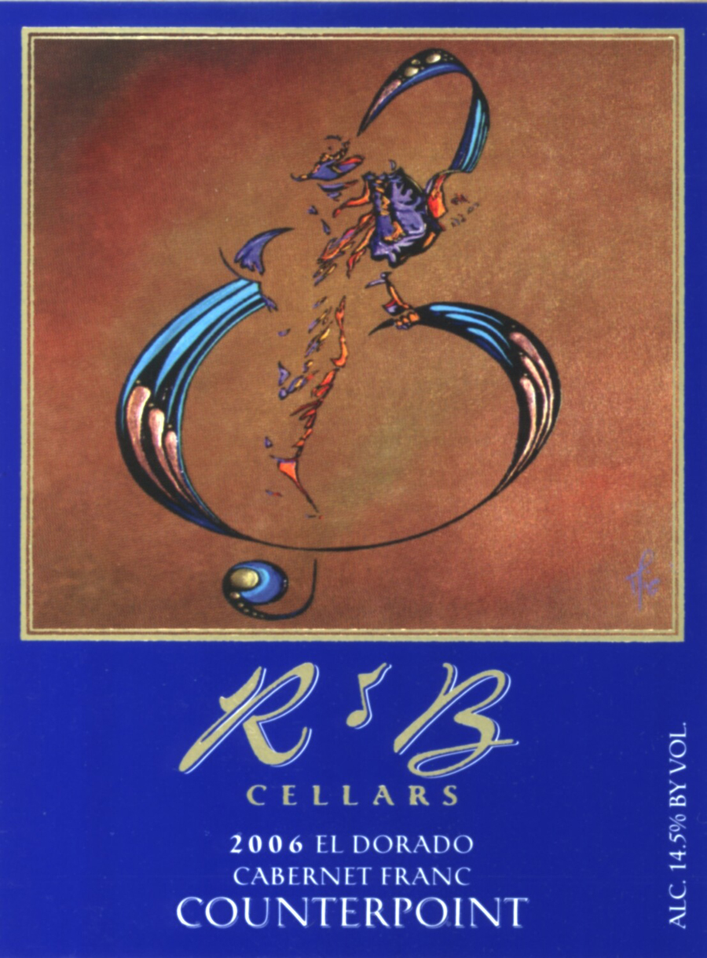 | R & B Cellars  El Dorado  2006 Counterpoint  Cabernet Franc
  Vineyards: | 100% Verbitsky Ranch
   | El Dorado Cabernet Franc
  Composition: | 100% Cabernet Franc
  Bottled: | February 2008
  Released: | April 2008
  Production: | 420 Cases

Vineyards

Sometimes you find a vineyard that is just perfect in every way. The fruit from it is magnificent and rich and it ends up making a wine that takes your breath away. The Verbitsky Ranch is just such a vineyard and the 2006 harvest yielded some incredible fruit. I only wish we could have gotten more. Nestled in the foothills of El Dorado, this old vine vineyard has low yields, which helps to produce some very rich and intense fruit.

The Wine

The fruit was crushed and fermented in tank with pump over’s twice a day. We started with a cold soak for 5 days before fermentation began to extract more flavors and color and we were richly rewarded. The wine was transferred to French oak barrels (60% new and 40% 2 year old) where it rested for 14 months. The wine was racked 4 times during the barrel ageing. It was then egg white fined and lightly filtered before bottling.

Winemaker’s Comments

Cabernet Franc is most often thought of as a blending wine for Cabernet Sauvignon. Its intense structure and exotic spice tones as well as its rich dark color are a perfect match for Cabernet Sauvignon. Sometimes, you get such intense fruit character that it would be a shame not to bottle it all by itself. This wine starts out like a lit firecracker and then explodes in the mouth with intense rich black berry fruit. Thick and opulent the dark fruit coats the palate before the exotic spice tones take over. Jammy and massive, the blackberry and cassis roll around in a mouth filling explosion of flavor before giving way to hints of toast and briar in the finish. NOT A WINE FOR WIMPS!

